
The Parish and Ward Church of
St Botolph-without-Bishopsgate
in the City of London
EC2M 3TL
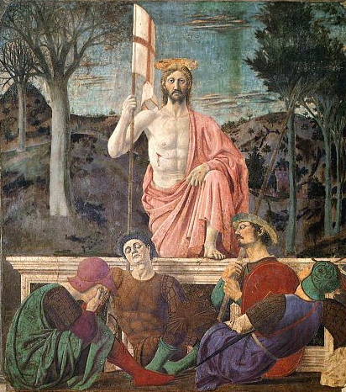

Piero della Francesca, c. 1465, Museo Civico di Sansepolcro

Choral Mass
in the week of The Fifth Sunday of Easter
Wednesday 6 May 2026 at 1.10 pm

The Revd David Armstrong, Rector Iestyn Evans, Director of Music

020 7588 3388 church@botolph.org.uk www.botolph.org.uk

St Botolph-without-Bishopsgate - a place of calm, sanctuary and God’s love in the City

Welcome to St Botolph-without-Bishopsgate
Fr David is on sabbatical until July; in his absence we are delighted to welcome Fr Peter McGeary, Vicar of St Mary’s Cable Street,
as celebrant and preacher.
If you have any comments on our new Choral Mass books, ahead of a professional print run, please send to office@botolph.org.uk.

Setting of the Mass: Petite Messe—Giulio Alary 1814–91

Opening Hymn: NEH 124 (verses 1-3, 5)
Ye choirs of new Jerusalem,  Your sweetest notes employ,  The Paschal victory to hymn  In strains of holy joy.  How Judah's Lion burst his chains,  And crushed the serpent's head;  And brought with him, from death's domains,  The long-imprisoned dead. | From hell's devouring jaws the prey  Alone our Leader bore;  His ransomed hosts pursue their way  Where he hath gone before.  While joyful thus his praise we sing,  His mercy we implore,  Into his palace bright to bring  And keep us evermore. Alleluya! Amen.

Gloria in excelsis: see the Mass book for translation of the Latin text

First Lesson: Acts 7: 55-end

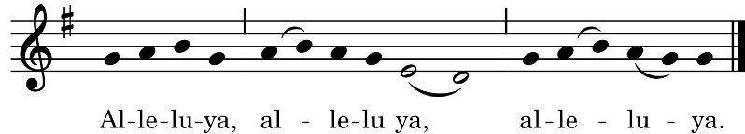
Gospel Acclamation
The refrain is sung first by the Cantor and then by all:
This verse is sung by the Cantor:
I have not spoken on my own, says the Lord, but the Father who sent me has given me a commandment about what to say and what to speak.
and the refrain is then repeated by all.

Gospel: S John 14: 1-14

During the singing of the Offertory Hymn a collection will be taken up for Christ’s work in this place. If you are a UK taxpayer please complete a Gift Aid envelope. If you prefer to make a contactless donation please use one of the devices at the front or back of church or the QR code on the back of this service sheet.

Offertory Hymn: NEH 114
Now is eternal life,  If risen with Christ we stand,  In him to life reborn,  And holden in his hand;  No more we fear death’s ancient dread,  In Christ arisen from the dead. | For God, the living God,  Stooped down to man’s estate;  By death destroying death,  Christ opened wide life’s gate.  He lives, who died; he reigns on high;  Who lives in him shall never die.
Unfathomed love divine,
Reign thou within my heart;
From thee nor depth nor height,
Nor life nor death can part;
Our life is hid in God with thee,
Now and through all eternity.

Sanctus, Benedictus, and Agnus Dei:
see the Mass book for translation of the Latin texts

Anthem during Communion:
Regina coeli laetare, Alleluia.
Quia quem meruisti portare, Alleluia.
Resurrexit sicut dixit, Alleluia.
Ora pro nobis Deum. Alleluia.
Joy to thee, O Queen of Heaven, alleluia.
He whom thou wast meet to bear, alleluia.
As he promised has arisen, alleluia.
Pour for us to God thy prayer, alleluia.
Eastertide Antiphon of the Blessed Virgin Mary Antonio Cifra c.1586–1629

Closing Hymn: NEH 107
Good Christian men, rejoice and sing!  Now is the triumph of our King:  To all the world glad news we bring: Alleluya!  The Lord of life is risen for ay:  Bring flowers of song to strew his way;  Let all mankind rejoice and say:  Alleluya! | Praise we in songs of victory  That Love, that Life, which cannot die,  And sing with hearts uplifted high:  Alleluya!  Thy name we bless, O risen Lord,  And sing today with one accord  The life laid down, the life restored:  Alleluya!

Organ music: Menuet Gothique Léon Boëllmann 1862-97

All are warmly invited to join us for refreshments following the service.

FORTHCOMING SERVICES & NOTICES
Church opening and service times
The church is open for public worship and private prayer every Monday to Friday from 7.30 am to 5.30 pm. Our normal service pattern is:
Tuesdays - Said Mass at 12.10 pm (This is now the only Mass on Tuesday)
Wednesdays - Choral Mass with sermon at 1.10 pm
Thursdays – Said Mass at 12.10 pm
Choral services are livestreamed on our YouTube channel
(accessible from the church website www.botolph.org.uk).
Tomorrow, Thursday 7 May: Mass at 12.10 pm
Next Tuesday, 12 May: Mass at 12.10 pm
Next Wednesday, 13 May: Choral Mass of S Matthias at 1.10 pm
Missa Tertia Octavi Toni Croce; Dederunt apostoli Handl;
Processional Mathias
Next Thursday, 14 May: The Ascension of our Lord
Choral Mass at 1.10 pm
Missa Ascendens Christus in altum Victoria; Ascendit Deus Philips
Heut triumphieret Gottes Sohn, BWV 630 Bach

At 6.00pm: ‘Sweet, stay awhile: Songs around Dowland’.
Concert from vocal ensemble Exaudi. Tickets £15 from exaudi.org.uk.

Can you help us financially?

- Cash donations (outside service times) may be placed in the alms boxes, or handed to a member of staff at any time. If you are a UK taxpayer please complete a Gift Aid envelope so we can claim back a further 25% from HMRC.

- Card/contactless donations can be made at any time via the device on the table at the back of church, or this QR code, and can be Gift Aided.
- Credit card donations can be made via the link on our website, and can be Gift Aided.

Electoral Roll Revision 2026 – DEADLINE TODAY
Being on the Electoral Roll allows you to shape your church’s mission and ministry by electing the officers necessary to do that hard work.
We encourage regular worshippers at St Botolph’s to apply:
even if you are already on the Roll at another church, you can be on the Roll here too. Please collect and complete a form after the service –
today is the last day before the Electoral Roll’s annual revision.

